Soil Composition Jar Test
- Objectives
  - Students will use the jar test method and a soil texture triangle to measure and determine soil type
- Related Indian Science Standards
  - 1.ESS.2 Observe and compare properties of sand, clay, silt, and organic matter. Look for evidence of sand, clay, silt and organic matter as components of soil.
- Vocabulary
  - Soil
  - Texture
  - Mineral
  - Clay
  - Sand
  - Silt
- Materials
  - Canning jar or similar glass or plastic container with flat parallel sides and secure lid
  - Enough soil to fill about half of the container
    - Try to get soil that is dry and free of large stones, roots, grass, etc.
  - Water
  - Permanent marker
  - Ruler (centimeter)
  - Optional as needed for filling the jar:
    - Funnel
    - Spoon
- Introduction
  - Soil composition is based on how much and what types of minerals are present in the soil. These minerals are sand, silt, and clay. Knowing how much of each is in your soil will help you make a good estimate of your soil type.
    - Sand particles are large and give lots of space for air and water to disperse throughout. However, this means that sandy soils can’t hold water and nutrients for very long. Sandy soils drain too quickly. Sand particles are the heaviest of the 3 mineral particles.
    - Clay particles are small and can hold water and nutrients much better than sand. However, it releases water very slowly, meaning that plant roots in clay-y soil will be wetter than most. Clay particles are the lightest of the 3 mineral particles.
    - Silt particles fall between sand and clay. The particles are heavier than clay but lighter than sand, so silt can hold water better than sand but not as well as clay can.
  - Most soils have a mix of all 3 types of particles, but at different amounts. Some soils may have so little of a certain type of particle that it is close to impossible to see it using this experiment.
  - Soil that has approximately equal parts sand, silt, and clay is called loam.
- Procedure
  - Part 1
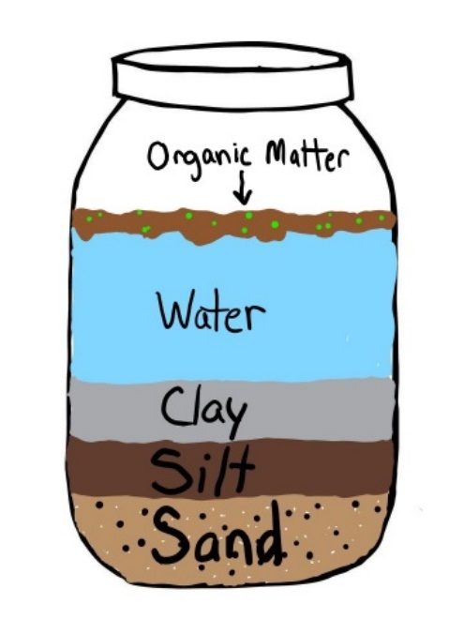
    - Fill your jar with soil, about halfway full.
    - Fill the jar to the top with water and secure the lid
    - Shake the jar for 2-3 minutes until the soil and water are well mixed
    - Leave the jar undisturbed for at least 24 hours until the soil particles have settled in layers.
    - Once the soil has settled (and depending upon the soil type) you should be able to see the three distinct layers. Sand, the heaviest particle, will be on the bottom. Silt will rest on top of sand, and clay (the lightest particle) will be on top. If your soil had any organic matter (like grass, roots, etc.) it will be floating at or near the top of the water
    - Us the permanent marker to mark the top of each layer
  - Part 2
    - Using the ruler, measure the total height of the mineral layers (soil height) in centimeters and write it down.
      - Total soil height: __________cm
    - Measure the height of each individual layer and record.
      - Sand layer height (bottom layer): __________cm
      - Silt layer height (middle layer): __________cm
      - Clay layer height (top layer): __________cm
    - Divide each layer by the total soil height and multiply by 100, then write it down.
      - (sand height/total soil height) x 100 = __________ %
      - (silt height/total soil height) x 100 = __________ %
      - (clay height/total soil height) x 100 = __________ %
- Conclusion
    - Use the soil triangle (below) to determine soil type
      - Find your percentage of clay from your soil on the chart. Draw a line across the texture triangle at that point. Repeat for silt and sand.
      - Find where your 3 lines intersect (or the approximate area). This is your soil type
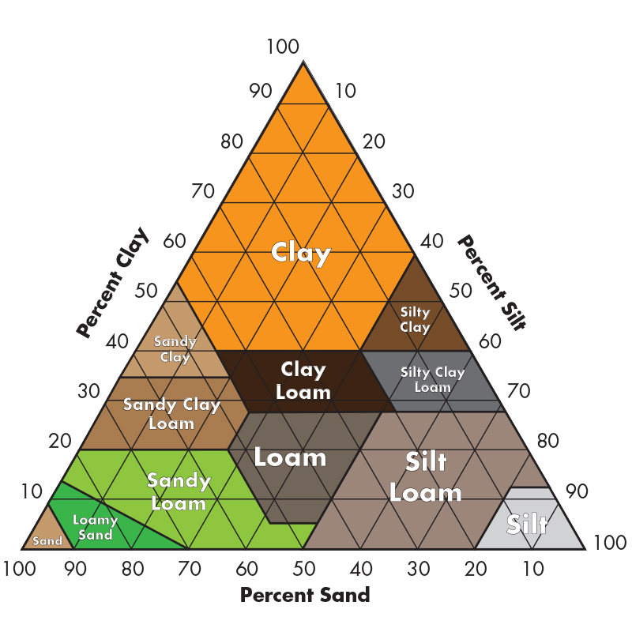
        - Soil texture type: __________________
- Resources
  - NRCS web soil survey (to find out your soil type)

