- Title
  - Weaving an Energy Web
- Objectives
  - Students will learn how energy is transferred from the sun and then between producers, consumers, and decomposers through the food web
- Standards
  - 4.LS.2 Use evidence to support the explanation that a change in the environment may result in a plant or animal will survive and reproduce, move to a new location, or die
  - 5.LS.1 Develop a model to describe the movement of matter among plants, animals, decomposers, and the environment
  - 5.LS.2 Observe and classify common Indiana organisms as producers, consumers, decomposers, or predator and prey based on their relationships and interactions with other organisms in their ecosystem
  - 6.LS.2 Describe the role of photosynthesis in the flow of energy in food chains, energy pyramids, and food webs. Create diagrams to show how the energy in animals’ food used for bodily processes was one energy from the sun
  - 6.LS.3 Describe specific relationships (predator/prey, consumer/producer, parasite/host) and symbiotic relationships between organisms. Construct an explanation that predicts why patterns of interactions develop between organisms in an ecosystem.
- Vocabulary
  - Producer
  - Consumer
  - Decomposer
  - Food web
  - Food chain
  - Energy
- Materials
  - Organism cards (see attached; print double-sided)
  - Large ball of yarn
- Introduction
  - All living things need energy for everything they do, and they get that energy from food. Green plants use energy from the sun to make their own food, animals get energy from eating those plants or from other animals that have eaten plants (or other animals). All energy for living things originally comes from the sun. Plants are considered producers (because they make their own food) and animals that eat plants or other animals are called consumers. When a plant or animal dies, they are broken down by organisms called decomposers (like bacteria, worms, and fungi).
    - Green plants (plants that contain chlorophyll which makes them green) use a process called photosynthesis to use the sunshine to make their food.
  - Energy transfers through food chains. Here is an example of a food chain:
    - Sun grass rabbit coyote
    - When the grass uses the sun to make food, the grass gets energy from that food. The rabbit that eats the grass gets energy from that grass, and the coyote that eats the rabbit gets energy from the rabbit.
  - Energy is also transferred through food webs, which are made up of multiple food chains that are interconnected. Here is an example of multiple chains that make up a food web:
    - Sun grass rabbit coyote bacteria
    - Sun clover caterpillar snake hawk
    - Sun corn chicken
- Procedure
  - Have students sit in a circle and give each student an organism card (you will probably need multiples of the cards. That’s okay! There can be more than one of each organism BUT there can only be one sun)
  - Choose one student to be the sun and sit in the middle of the circle. This student will also hold the end of the yarn. The sun is the center of the energy web because all energy comes from the sun.
  - After getting their organism cards and sun card, have each student go around the circle and say what organism they are.
  - Explain to students that their job will be to make energy connections between each organism starting with the sun. They can include the sun in their connections as well.
  - Beginning with the sun, pass the yarn ball around the circle, making connections between organisms and the sun
    - Ex. “I am the sun and I feed the grass” (sun tosses the ball to grass. The grass holds the yarn)
    - “I am grass and my seeds feed the red-winged blackbird” (Still holding the yarn, grass tosses the ball to red-winged blackbird)
    - “I am a red-winged blackbird and I warm myself in the sun” (still holding the yarn, red-winged blackbird tosses the ball back to the sun. You should see a web beginning to form after three or four connections)
  - Continue making connections until every student is part of the yarn web.
- Closure
  - Remind students that food chains are interconnected and that this is how the food web is created. What would happen to the food web if a certain organism was suddenly gone? Call on different organisms to drop their yarn. Have students make observations about what happens to the web when certain organisms drop their yarn. What would happen if the sun was gone? Have the sun drop its yarn. Have students make observations about what happens to the web without the sun.

Sun  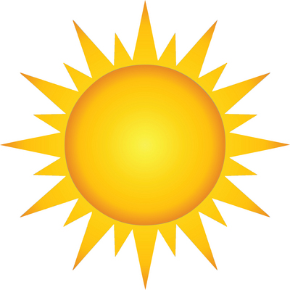  This Photo by Unknown Author is licensed under CC BY-SA | Tree  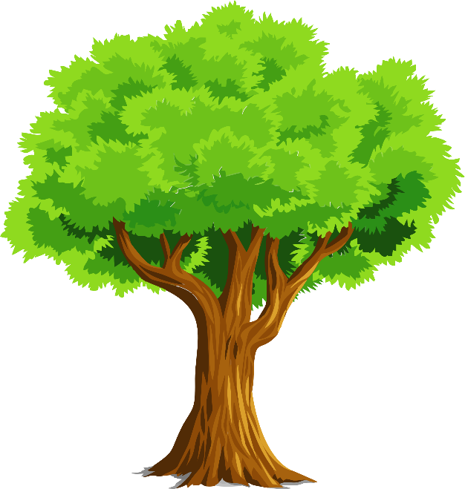
Grass  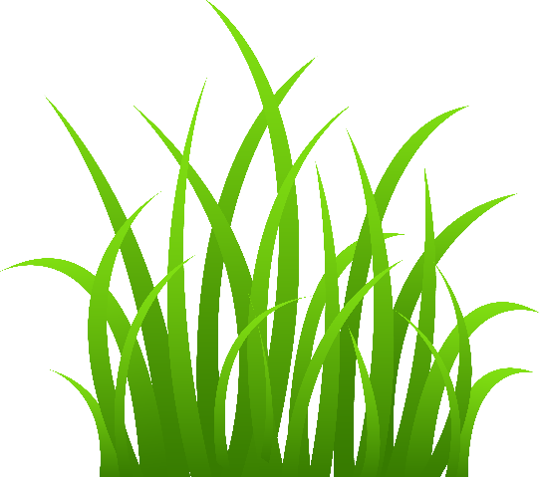  This Photo by Unknown Author is licensed under CC BY-SA-NC | Corn  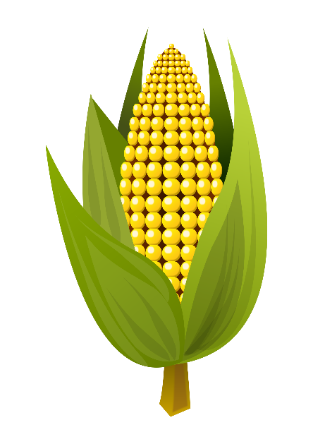

Tree  - Producer  - Leaves can be eaten by caterpillars | Sun  - Source of all energy  - Helps green plants create food (in this case, trees, corn, and grass)
Corn  - Producer  - Can be eaten by red-winged blackbirds and chickens | Grass  - Producer  - Can be eaten by red-winged blackbirds, chickens, ducks, and rabbits

Chicken  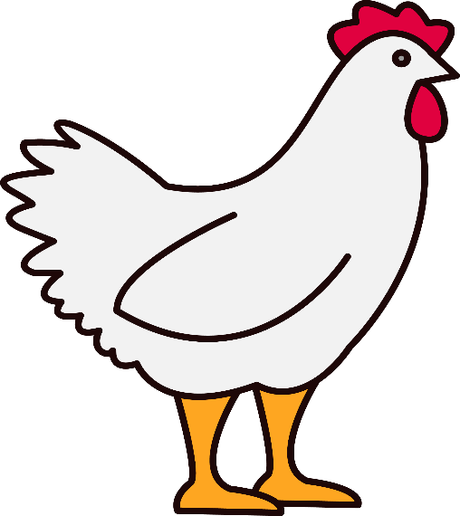  This Photo by Unknown Author is licensed under CC BY-SA-NC | Red-winged blackbird  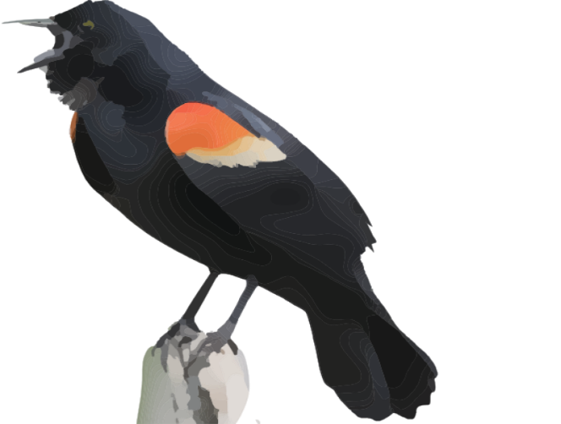
Duck  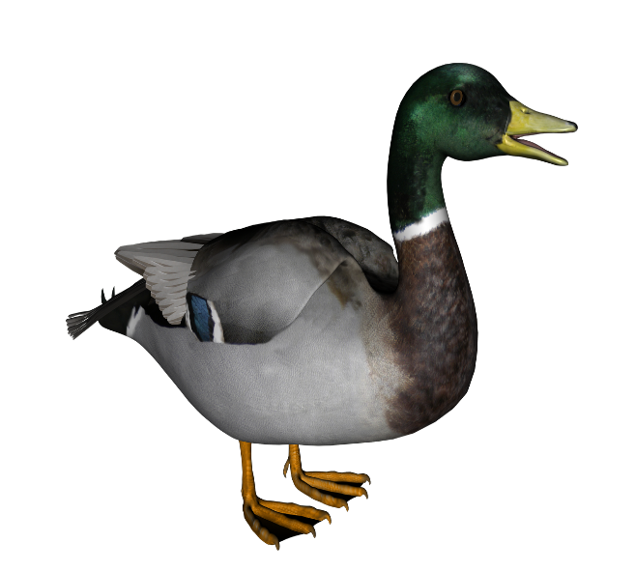  This Photo by Unknown Author is licensed under CC BY-NC | Fox  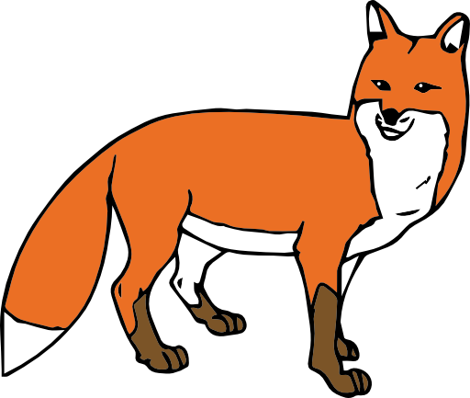  This Photo by Unknown Author is licensed under CC BY-NC

Red-winged blackbird  - Consumer  - Can eat grass seeds, corn, and caterpillars  - Can be eaten by foxes and coyotes  - Can be broken down by decomposers | Chicken  - Consumer  - Can eat grass and corn  - Can be eaten by foxes and coyotes  - Can be broken down by decomposers
Fox  - Consumer  - Can eat chickens, red-winged blackbirds, ducks, and rabbits  - Can be broken down by decomposers | Duck  - Consumer  - Can eat grass  - Can be eaten by foxes and coyotes

Coyote  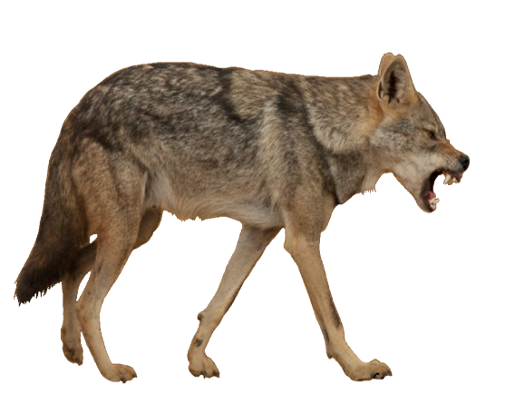  This Photo by Unknown Author is licensed under CC BY-SA | Rabbit  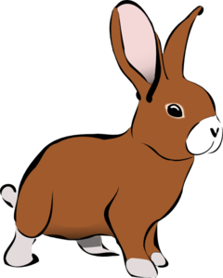  This Photo by Unknown Author is licensed under CC BY-SA-NC
Caterpillar  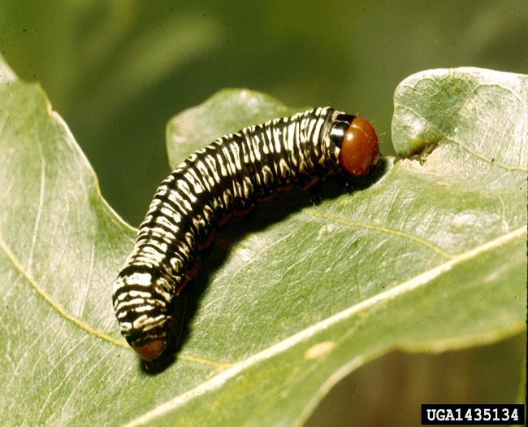  This Photo by Unknown Author is licensed under CC BY-SA | Ant  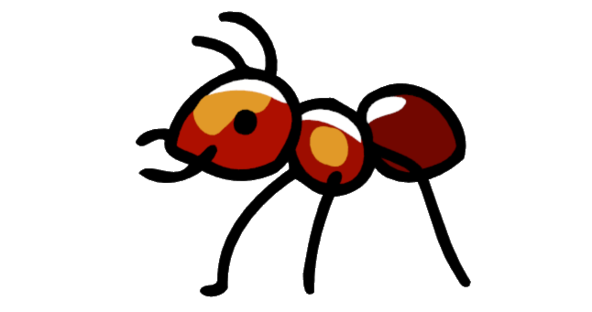  This Photo by Unknown Author is licensed under CC BY-NC

Rabbit  - Consumer  - Can eat grass  - Can be eaten by fox or coyote  - Can be broken down by decomposers | Coyote  - Consumer  - Can eat chickens, ducks, and rabbits  - Can be broken down by decomposers
Ant  - Decomposer  - Can break down consumers | Caterpillar  - Consumer  - Can eat tree leaves  - Can be eaten by red-winged blackbird

Worm  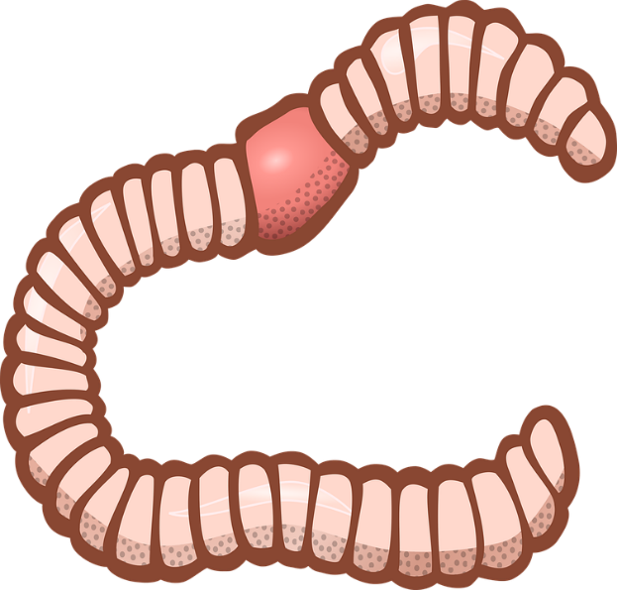 | Bacteria  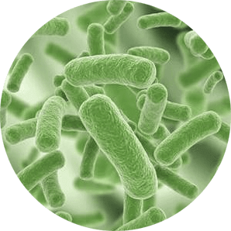  This Photo by Unknown Author is licensed under CC BY-NC

Bacteria  - Decomposer  - Can break down dead consumers | Worm  - Decomposer  - Can break down dead consumers  - Can be eaten by chickens, ducks, and red-winged blackbirds

